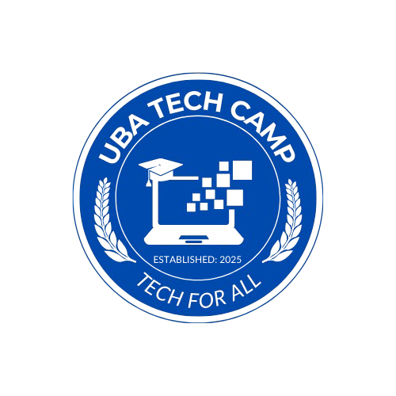

THE UNIVERSITY OF BAMENDA
Knowledge – Probity – Entrepreneurship
UBA TECH CAMP
Tech for All
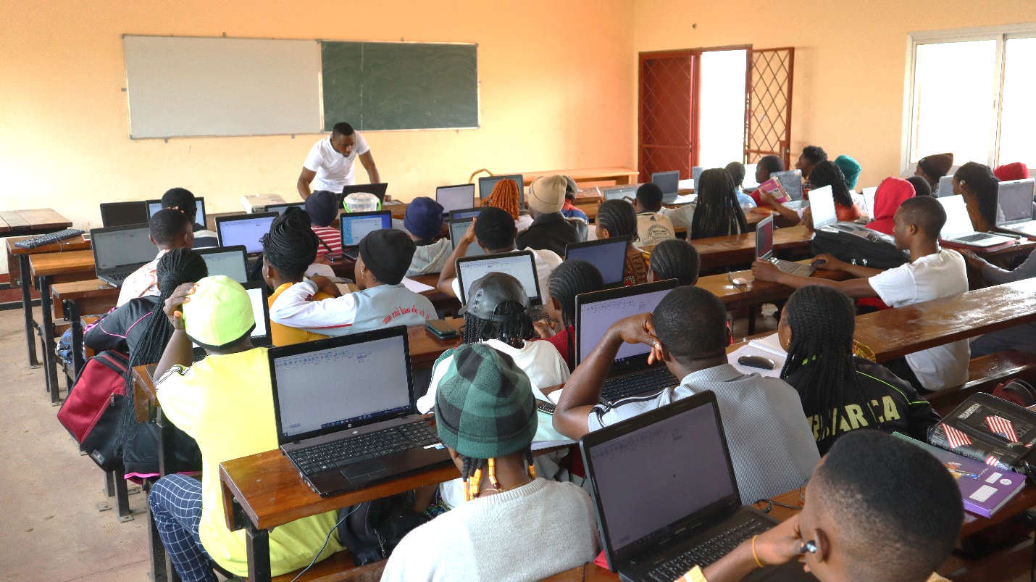
Contact: +237 671 308 991 Email: info.ubatechcamp@gmail.com

Presented By
JAM RANSOM
Founder, UBa Tech Camp

Submitted to
THE DIRECTOR OF STUDENT AFFAIRS
IGNITING DIGITAL SKILLS AT THE UNIVERSITY OF BAMENDA
PROGRAM REPORT

Executive Foreword
As the founder of the UBa Tech Camp and the visionary behind this initiative, I am deeply proud of what we have accomplished together over the past month. When we launched this program, we had one clear mission: to equip students with the digital skills they need to succeed in today’s fast-changing world.
At the heart of this mission was the belief that young people at the University of Bamenda hold enormous potential. What they needed was opportunity, the chance to access the tools, the training, and the confidence to take their ideas forward. With the dedication of our facilitators, the support of the university, and the incredible determination of the students, we have seen that vision come to life.
The success of this first camp is just the beginning. As we look to the future, we are excited to expand this work, adding new subjects like programming and entrepreneurship, and bringing even more students into the fold. We are also eager to welcome partners, mentors, and supporters who share our commitment to digital empowerment.
Thank you to everyone who contributed to this achievement. Together, we are not just training students, we are igniting a movement of innovation, leadership, and opportunity at the University of Bamenda.
Jam Ransom, Founder, UBa Tech Camp

Executive Summary
The UBa Tech Camp was held at the University of Bamenda between February and March 2025. Over one month, more than 60 students took part in this exciting and practical program. Created by Jam Ransom, the camp was designed to give students hands-on digital skills, including Microsoft Office tools and data analysis software, which are crucial for both their schoolwork and future careers. Importantly, the program was offered entirely free of charge, making it even more valuable as it provided students access to skills that are highly needed in today’s economy.
The training sessions were held at UBaDef Hall 3 and were led by three passionate facilitators: Abongni Kevin, Angu Princewill Fon, and Yembi Desmond. Students didn’t just listen to lectures, they learned by doing. They practiced writing reports in Word, analyzing data using Excel and SPSS, and designing presentations in PowerPoint. The program was thoughtfully planned to cover both simple and advanced tasks, giving students a wide range of abilities to build on.
This report explains the camp’s goals, how it was organized, and the outcomes it produced. It also discusses the challenges faced during the program, how student progress was measured, and suggestions for improving future editions. Overall, the UBa Tech Camp not only boosted students’ digital skills but also created a lively and collaborative environment where they could share ideas and gain confidence. Its success has opened the door for even bigger and better programs in the years to come.

Introduction
In today’s world, digital skills are no longer optional, they are essential. Whether it’s preparing assignments, analyzing data, or creating presentations, students need to know how to use tools like Microsoft Office and SPSS to succeed in both school and work. Yet, many students at the University of Bamenda struggle with these tools because they have never had proper training or access to them.
The UBa Tech Camp was created to help close this gap. It was designed to give students practical, hands-on experience with some of the most widely used digital tools. Unlike regular classroom lessons that often focus on theory, the camp focused on real-world practice, helping students apply what they learned right away.
Beyond academic success, the camp aimed to improve students’ career prospects by giving them tools that are highly valued in the workplace. It also aimed to boost their ability to take part in digital entrepreneurship, helping them see how technology can be used not just to get a job, but to create opportunities, start businesses, or offer services online.
Looking ahead, the program also hopes to introduce basic programming skills in future editions. By adding programming, students will not only use existing tools but also learn how to build their own solutions, further strengthening both their academic and entrepreneurial paths.
By offering this training, the UBa Tech Camp gave students a space where they could learn, practice, make mistakes, and grow, all while working alongside their peers and preparing for a more digital future

Background and Rationale
In today’s world, digital skills are not just an advantage, they are a necessity. Whether in the classroom, the workplace, or the marketplace, the ability to use digital tools effectively can open doors and create life-changing opportunities.
At the University of Bamenda, many students are eager to learn these skills, but they often face real barriers. Limited access to computers, lack of formal training, and gaps in hands-on experience leave many young people underprepared for the demands of modern academic work and an increasingly digital job market.
The UBa Tech Camp was designed as a direct response to these challenges. The program’s goal was to close the digital skills gap by offering students free, practical training in tools like Microsoft Office and IBM SPSS, tools that are used every day in classrooms, offices, businesses, and research institutions around the world.
But beyond academic success, the program was also created to spark digital entrepreneurship. We wanted students not just to use technology, but to see its potential for creating solutions, launching ideas, and building businesses. By introducing real-world projects, teamwork, and mini-assignments, the camp encouraged students to think creatively and practically about the role of technology in their futures.
In short, the UBa Tech Camp was not just a training program. It was a response to an urgent need, a commitment to opportunity, and a first step in building a stronger, more digitally empowered university community.

Objectives
The UBa Tech Camp was designed with several important goals in mind. At its heart, the program aimed to help students gain practical digital skills that would support their studies and open doors for their future careers. But the camp went even further than that.
First, it aimed to strengthen students’ abilities to use key digital tools, especially Microsoft Office (Word, Excel, PowerPoint) and IBM SPSS for data analysis. These are tools that students often need for writing assignments, organizing research, and preparing presentations.
Second, the camp wanted to boost students’ confidence in applying these skills not only in school but also in the workplace. By learning to use digital tools effectively, students improve their chances of finding jobs and advancing in their chosen fields.
Third, the program had a strong focus on digital entrepreneurship. It encouraged students to think creatively about how they could use technology to solve problems, start small businesses, or offer services online. This mindset is especially important in today’s economy, where digital skills can help create new income opportunities.
Finally, while the first edition of the camp focused on Office tools and data analysis, future programs plan to introduce basic programming skills. This will help students take an even bigger step forward, moving from using digital tools to building their own solutions, apps, or online platforms.

Training Methodology
The UBa Tech Camp was carefully designed to help students learn as much as possible in a short time. The program took place over one month, from February to March 2025, and was divided into two main parts.
The first part focused on Microsoft Office tools, Word, Excel, and PowerPoint, while the second part introduced students to IBM SPSS for data analysis. Each week was dedicated to a specific set of skills so that students could dig deep into the tools and really understand how to use them.
All the training sessions were held at UBaDef Hall 3, right on the University of Bamenda campus. Instead of using formal computer labs, students worked in a classroom setting, often sharing laptops and working together in small groups. This approach encouraged teamwork and made sure that even students who didn’t own personal devices could fully participate.
The training was intense and immersive. Students learned simultaneously and intensively every day, from 8:00 a.m. to 4:00 p.m. To reinforce what they learned during the week, they were also given mini projects every weekend. These projects allowed them to apply their new skills in creative ways and often required teamwork, giving them valuable experience working in groups.
The facilitators, Abongni Kevin, Angu Princewill Fon, and Yembi Desmond, played a key role throughout. They guided the students, answered questions, and kept the sessions engaging and interactive. This hands-on, group-based approach helped create a lively learning atmosphere where students were encouraged to practice, experiment, and learn from both their successes and their mistakes.

Program Breakdown
The UBa Tech Camp followed a well-structured timetable that stretched over one month, combining learning, practice, and teamwork. Each week was carefully designed to build students’ skills step by step while keeping them engaged through mini projects and group activities.
Week 1–2: Microsoft Office Suite
The first two weeks focused on building confidence with Microsoft Office tools. Students started with Microsoft Word, learning how to format documents, use styles, create tables, and insert graphics. They practiced using collaboration tools like track changes, comments, and mail merge, which are valuable for both academic and workplace tasks.
Next came Microsoft Excel, where students learned basic and advanced formulas like SUM, AVERAGE, IF, VLOOKUP, and HLOOKUP. They also practiced data cleaning, dashboard creation, financial modeling, and forecasting. The introduction of Power Query and pivot tables pushed their Excel skills to a more advanced level.
For Microsoft PowerPoint, students worked on designing professional slides, using themes, adding SmartArt, animations, transitions, and polishing their final presentations. They learned how to combine slides smoothly and apply consistent branding, which helped them create polished and engaging slide decks.
Week 3–4: IBM SPSS for Data Analysis
The second half of the camp was dedicated to IBM SPSS, a key software tool for data analysis. Students began with the basics, like entering and cleaning data, before moving on to descriptive statistics such as mean, median, and standard deviation. They then explored hypothesis testing, frequency tables, cross-tabulations, regression analysis, and even multivariate techniques like principal component analysis (PCA) and cluster analysis.
An exciting feature of this part of the program was data storytelling, where students practiced turning numbers and data into clear, compelling stories, an essential skill in both research and business.
Daily Schedule and Mini Projects

Students learned intensively, working from 9:00 a.m. to 4:00 p.m. each day. They alternated between software and data analysis sessions, ensuring a balanced mix of technical and analytical practice. Every weekend, they worked on mini projects that allowed them to apply what they had learned during the week. These projects covered combinations of Word, Excel, PowerPoint, and SPSS and encouraged teamwork, creativity, and problem-solving.
Final Assessments and Presentations
Toward the end of the camp, students worked on final presentations and reports, combining all the skills they had gained. The program wrapped up with a comprehensive assessment, where students were evaluated on Word, Excel, PowerPoint, and SPSS through one final mini project, a rewarding challenge that allowed them to showcase their growth and achievements.

Key Achievements
The UBa Tech Camp reached several important milestones that showed just how successful the program was.
First and most importantly, the camp trained over 60 students, giving them practical, hands-on experience with Microsoft Office tools and IBM SPSS. For many participants, this was their first time working confidently with software that is widely used in academic research, workplaces, and even in entrepreneurship.
Students didn’t just learn theory, they applied their skills to real projects and assignments. By the end of the program, participants were able to prepare professional reports, create dynamic presentations, clean and analyze data, and even explain complex statistical results. Many students mentioned that they could already see how these skills would improve their schoolwork and help them in the job market.
One of the most impressive outcomes was the high level of engagement and teamwork. Students worked closely in groups, sharing laptops, solving problems together, and helping each other improve. The group work, especially during the mini projects and final assessments, strengthened not only their technical abilities but also their communication, leadership, and collaboration skills.
Another key achievement was the boost in confidence reported by students. Many came into the program feeling unsure about using these tools, but by the end, they were confident enough to analyze real data sets and present their findings. Several students also showed strong interest in expanding their learning into new areas like programming and digital entrepreneurship.
Overall, the UBa Tech Camp not only equipped students with valuable digital skills but also sparked their curiosity and ambition to go further, a true sign of success.

Student and Facilitator Testimonials
The impact of the UBa Tech Camp was perhaps felt most clearly through the voices of the students and facilitators themselves. Their words, as seen on the camp’s Facebook and LinkedIn pages, tell the story of a program that didn’t just teach, it inspired.
Student Testimonials
“UBa Tech Camp has given me the tools I need to succeed. Before this, I was afraid to even open SPSS, but now I’m confident using it for my research projects. I feel ready for my thesis work!”, Student, Faculty of Science
“The hands-on learning approach was the best part for me. We didn’t just watch someone explain things, we practiced it ourselves. I can now use Excel for both my studies and for personal things like budgeting. It’s a huge improvement for me.”, Student, Faculty of Social Sciences
“Working in groups really helped me. We supported each other, and I learned so much from my teammates. It wasn’t just about learning software, it was about learning to work as a team.”, Student, Faculty of Economics and Management
Facilitator Testimonials
“It was incredible to see students grow from being unfamiliar with tech tools to confidently applying them. Their enthusiasm was truly inspiring. By the end of the camp, many were asking for more, they wanted to learn programming next!”

“The collaborative environment was one of the most rewarding aspects of this camp. We saw students helping each other, sharing laptops, and building solutions together. It was amazing to watch them transform over just a few weeks.” Desmond Yembi

Challenges and Solutions
Like any meaningful program, the UBa Tech Camp faced a few challenges along the way. However, what stood out was how quickly and creatively both the organizers and participants worked together to overcome them.
Limited Laptop Access
One of the biggest challenges was the limited number of laptops available for students. Many participants did not own personal devices, and this could have been a major obstacle. To solve this, the facilitators organized students into small groups, allowing them to share laptops and work together on tasks. While this meant students had to be patient and take turns, it also encouraged teamwork and peer learning, which became one of the strengths of the program.
Time and Space Management
With over 60 students participating, managing the available space and keeping sessions organized was not always easy. The team addressed this by adjusting the daily schedule and breaking students into rotating groups. This ensured everyone got enough hands-on time and the classroom environment remained productive and orderly.
Intensive Daily Schedule
The program ran daily from 9:00 a.m. to 4:00 p.m., which was intensive and sometimes tiring for both students and facilitators. However, students were highly motivated, and the addition of mini projects on weekends helped keep energy levels up. These projects allowed students to apply what they had learned during the week in a more creative and relaxed setting, balancing the demanding pace of the training.
Different Skill Levels
Participants came into the camp with very different levels of experience, from beginners to more advanced learners. The facilitators managed this challenge by providing individual support, adjusting tasks when needed, and encouraging peer assistance within groups. This helped create an inclusive environment where no one was left behind

Stakeholder and Partner Acknowledgements
The success of the UBa Tech Camp was made possible not only by the hard work of the organizing team and facilitators, but also by the invaluable support of several key stakeholders and partners who helped pave the way for the program’s reach and smooth delivery.
We would like to express our heartfelt thanks to Mr. Yve, President Emeritus of FEMSA (FEMS Students Association) and Mr. Nanguat Blaise, President Emeritus of NAHPISA (NAHPI Students Association). Both leaders played a critical role in spreading the word about the camp across their respective faculties and schools, ensuring that students knew about this opportunity and were encouraged to participate.
We are also deeply grateful to the Director of Student Affairs, whose guidance was instrumental in communicating with the university administration. His help was key in securing institutional support and, most importantly, arranging access to a venue where students could comfortably learn and collaborate.
Finally, we sincerely acknowledge Mr. Kongyuy Patrick, the University Registrar, who kindly authorized the use of UBaDef Hall 3 during the holiday period. His support allowed us to run the program in a space that was accessible, well-equipped, and conducive to effective learning.
Together, these stakeholders demonstrated outstanding commitment to student development and digital empowerment. Their contributions ensured that the UBa Tech Camp was not only well-organized, but also deeply rooted in the university community.

Impact Assessment and Results
To understand how well the UBa Tech Camp met its goals, the organizers used several methods to assess the program’s impact and the students’ progress.
Pre- and Post-Training Surveys
Before the camp began, students filled out surveys to measure their starting skills and confidence with tools like Microsoft Office and SPSS. After the camp, they completed another survey to show how much they had improved. The results were impressive, over 85% of students reported a significant increase in confidence when using these digital tools, especially for school projects, research, and even entrepreneurial ideas.
Hands-On Projects and Mini Assignments
Throughout the camp, students worked on mini projects every weekend and practiced their skills during daily sessions. These activities gave facilitators a chance to observe student progress closely. By watching how students applied what they had learned, facilitators could identify both strengths and areas where extra support was needed.
Facilitator Feedback and Observations
Facilitators kept a close eye on student participation, group collaboration, and problem-solving during the sessions. They provided immediate feedback and encouraged students to help each other, which boosted both learning and teamwork. This hands-on approach allowed facilitators to track individual and group progress in real time.
Final Assessments and Presentations
At the end of the program, students completed a comprehensive mini project that combined all their new skills, from Word and Excel to PowerPoint and SPSS. They also gave final presentations, showcasing not just their technical ability but also their growth in communication, critical thinking, and teamwork.
Overall Results
The assessment showed clear gains across the board. Students left the camp with stronger digital skills, more confidence, and a better understanding of how to apply what they learned in both academic and professional settings. Many expressed interest in learning programming and exploring digital entrepreneurship, showing that the camp had sparked a hunger for continuous learning.
UBaTech Camp Pre- and Post-Training Survey Results
Skill Area | Pre-Training (%) | Post-Training (%)
Microsoft Word | 30 | 85
Microsoft Excel | 25 | 90
Microsoft PowerPoint | 20 | 88
IBM SPSS | 15 | 80
Data Analysis | 18 | 82
Teamwork & Collaboration | 40 | 95
Confidence with Digital Tools | 20 | 95

Financial Summary and Resource Use
Although the UBa Tech Camp was offered free of charge to students, it required careful use of financial and non-financial resources behind the scenes to make it a success. Transparency about how these resources were used helps highlight the deep commitment and generosity of those who made the program possible.
Venue and Equipment
The program was able to use UBaDef Hall 3 during the holiday period thanks to the authorization of the University Registrar and the support of the Director of Student Affairs. This space provided an ideal setting for learning and teamwork. Students were encouraged to bring their own laptops when available, and where needed, they worked in groups to share devices.
Human Resources and Logistics
A major strength of the camp was the remarkable commitment of the founder, Jam Ransom, and the facilitators, Abongni Kevin, Angu Princewill Fon, and Yembi Desmond. Together, they not only provided their time and expertise on a voluntary basis but also personally supported the program’s logistical needs. This included organizing supplies, setting up equipment, and covering any small expenses needed to ensure the smooth running of the camp.
Materials and Supplies
Basic materials such as markers, flip charts, notebooks, internet connectivity, and refreshments were provided and funded directly by the founder and facilitators. Students were asked to bring USB flash drives to install software and save their work, helping keep the program cost-efficient.
Estimated Budget Overview
Item | Provided By
Venue (UBaDef Hall 3) | Authorized free by University Registrar
Facilitator Time | Voluntary contribution by facilitators
Materials & Logistics | Covered by founder and facilitators
Student Equipment | Personal laptops + group sharing

The UBa Tech Camp stands as a powerful example of what can be achieved when dedicated individuals come together to invest in student growth. By relying on voluntary contributions and resourceful planning, the camp delivered high-impact training without relying on external funding, a model that shows both generosity and sustainability.

Sustainability and Future Plans
The UBa Tech Camp was not designed to be a one-time event, it was meant to spark an ongoing journey of digital growth at the University of Bamenda. To ensure the program’s long-term success and expand its impact, several strategies are being considered.
Quarterly Programs
One of the main recommendations is to organize the camp on a quarterly basis. This would allow even more students to benefit from the training and help build a culture of digital literacy across the university. By offering multiple sessions throughout the year, the program can reach students from different faculties and levels of study.
Expanding the Curriculum
While the current program focused on Microsoft Office and SPSS, future editions aim to introduce web development, basic programming, and coding. Adding these subjects will equip students with even more versatile skills, opening doors to opportunities in tech careers and digital entrepreneurship.
Building Partnerships
Collaborating with local tech companies, organizations, and university departments is another key step. These partnerships can provide resources such as equipment, guest trainers, internship opportunities, and even sponsorship, making the camp stronger and more sustainable.
Peer Mentorship and Alumni Involvement
A long-term vision for the camp includes developing a peer mentorship model, where past participants and senior students return as assistant trainers or mentors. This approach not only helps sustain the program but also empowers students to step into leadership roles and give back to their community.
The success of the first UBa Tech Camp has laid the foundation for a growing movement. With thoughtful planning, strong partnerships, and ongoing student involvement, this program can continue to grow, reaching even more young people and helping them thrive in a digital world.

Media and Communications Summary
The success and excitement of the UBa Tech Camp extended far beyond the classroom walls, reaching the wider university community and the public through social media and online platforms. This media presence played an important role in amplifying the program’s impact and inspiring future participants.
Social Media Engagement
Throughout the program, students and facilitators actively shared their experiences on Facebook and LinkedIn, posting photos, reflections, and testimonials. These posts captured real-time moments of learning, teamwork, and celebration, helping to spread the camp’s message of empowerment across the university and beyond.
Key highlights from social media included:
Posts from participants celebrating their new skills and thanking the facilitators
Group photos showing teamwork during weekend mini projects
Behind-the-scenes updates from facilitators about daily sessions
Posts by faculty leaders and student association heads endorsing the camp and encouraging others to join
Online Reach
The camp’s presence on social media generated meaningful engagement, including:
Dozens of student testimonials praising the practical nature of the program
Comments and reactions from faculty members, alumni, and peers
Shares and reposts that expanded awareness of the camp to other faculties and schools
Value of Public Visibility
The media and communications efforts not only built excitement around the camp but also helped establish its credibility as a valuable initiative. This visibility has already started opening doors for future collaborations, with other students, faculty members, and potential partners expressing interest in supporting or participating in future editions.

Conclusion
The UBa Tech Camp has been more than just a training program, it has been a transformational experience for over 60 students at the University of Bamenda. Over the course of one month, students moved from uncertainty to confidence, from basic familiarity to hands-on expertise in tools like Microsoft Office and IBM SPSS.
But the impact of the camp goes beyond technical skills. It created a space where students learned to work together, solve problems, and discover their own potential. It opened their eyes not only to academic success but also to the possibilities of digital careers and entrepreneurship.
The program’s success is a clear sign that students are eager to learn, and that when given the right support, they can achieve remarkable growth in a short time. Thanks to the hard work of the facilitators, the support of the university, and the enthusiasm of the students, the UBa Tech Camp has set a powerful example of what’s possible when we invest in young people.
Looking ahead, the goal is to expand and sustain this momentum, reaching even more students, adding new subjects like programming, and building partnerships that will help secure the future of the program. The UBa Tech Camp has laid a strong foundation, now it’s time to build on it and keep igniting digital talent for years to come

Appendix A: Detailed Program Schedule
The following table provides an overview of the detailed schedule followed during the UBa Tech Camp, covering the four weeks of training. This appendix offers readers a closer look at the sequence of topics, the structure of the daily sessions, and the learning flow across the program

Contact Information and Call to Action
For more information about the UBa Tech Camp, future programs, partnerships, or volunteer opportunities, please contact:
UBa Tech Camp Team
Phone: + 237 671 308 991
Whatsapp: + 237 671 308 991
Email: info.ubatechcamp@gmail.com
Social Media
Facebook: @ UBa Tech Camp
LinkedIn: UBaTech Camp

